Traveling Salesman: An NFL Scheduling Problem

David Graves
Colorado State University Global
CSC506
Dr. Brian Holbert
April 7, 2025

Setting up the Experiment
Having set the table for my project by drafting a project plan in the first portfolio milestone, the next steps include algorithm implementation and testing. As previously discussed, this project is aimed at exploring and comparing different algorithmic performance in solving the Traveling Salesman Problem. I’ll use the remainder of this paper to share what algorithms were used showing their implementation against various data inputs while collecting empirical data that will be used later in the project to determine quality of answer and time complexity needs of each algorithm.
Drafting the Maps
To gather meaningful measurements from the algorithms, I’ve chosen to draft three different real-world data sets to test based on NFL (National Football League) schedules. The hypothetical “salesman” trips will follow what it would look like for the Denver Broncos to travel to; 1. All the other 3 AFC West teams (Data set A – 4 city trip), 2. All AFC West and East teams (Data set B – 8 city trip), and 3. All AFC West, East and South teams (Data set C – 12 city trip). I will use three different algorithms including ‘Nearest Neighbor’, ‘Minimum Spanning Tree’, and ‘Genetic’ implementations on all 3 data sets that vary in size and complexity to gather the data. I’ve mapped direct distance in miles between each city using an online resource “Distance-Cities.com” (2025) to create the tables to use for the experiment. All three data sets are shown below in Image 1 as a map for reference. Now that we understand all the cities our team (Denver Broncos) must visit at least once prior to returning home, the next step is to implement the different algorithms and capture the resulting maps for trip quality and time to program execution.
Image 1 (Map with Teams)
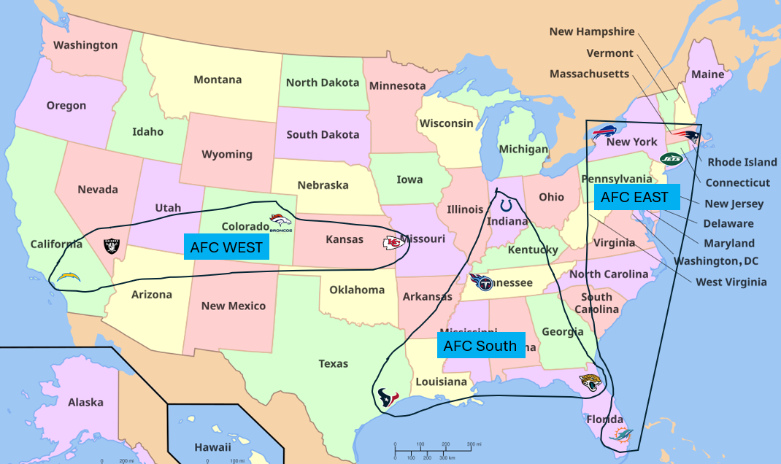
Running the Experiment
I chose to implement and explore three different algorithms against the map above with different levels of complexity ranging from a 4-city trip to a 12-city trip to better understand how the underlying algorithms react and perform. In addition to the actual path each algorithm traveled, direct measurements gathered include accuracy, which is measured by the algorithm finding the shortest trip across the cities, and time which was measured by the time it takes each program to run the data set from start to finish. To build a complete picture, I ran each algorithm against each Data Set (A-C) and ended up with 9 results to study for accuracy and timeliness. I ended up having to bolt on a timer to each algorithm to measure the timeliness for the experiment, and the mileage was tracked as part of the algorithmic input and subsequent output in miles. The following set of Images are labeled by Algorithmic name and the Data Set that was used for each of the implementations, and the final Image is a table showing all the results in an easily consumable format.
Nearest Neighbor Data Set A 4-city
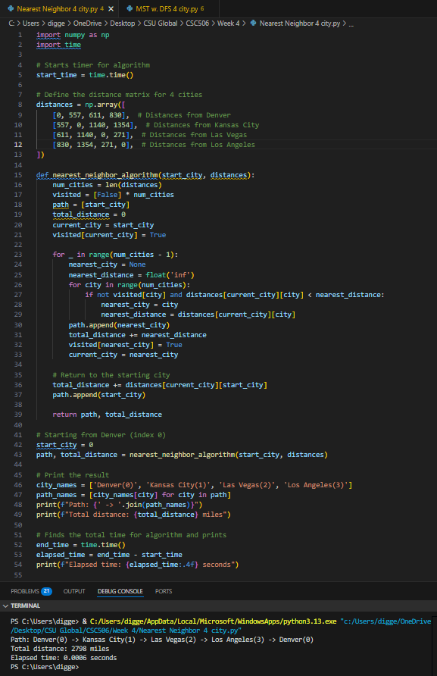
Minimum Spanning Tree Data Set A 4-city
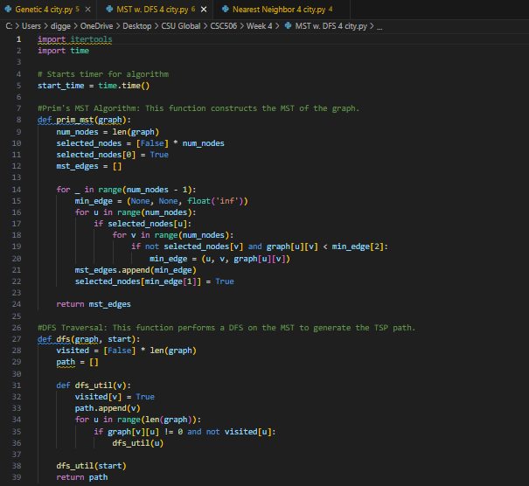
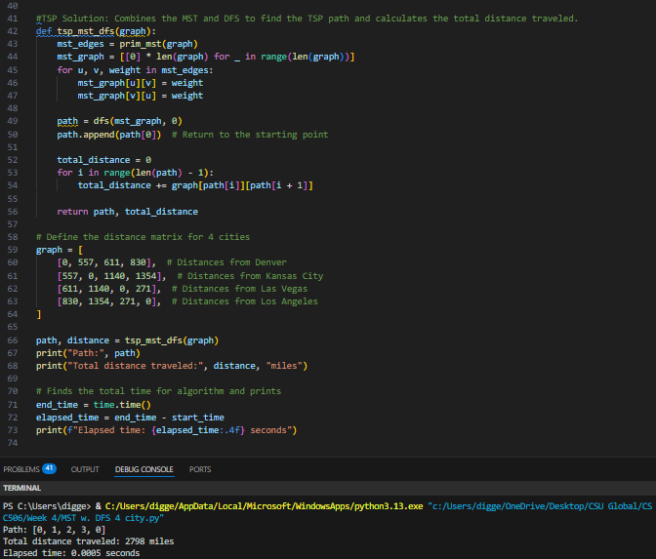
Genetic Data Set A 4-city
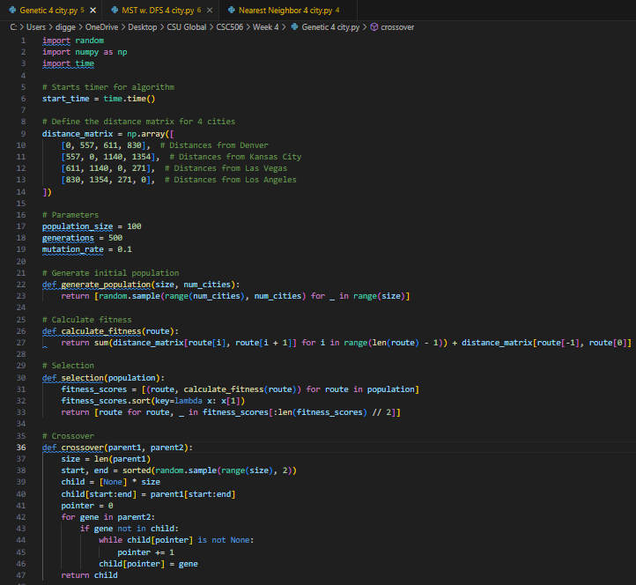

Nearest Neighbor Data Set B 8-city
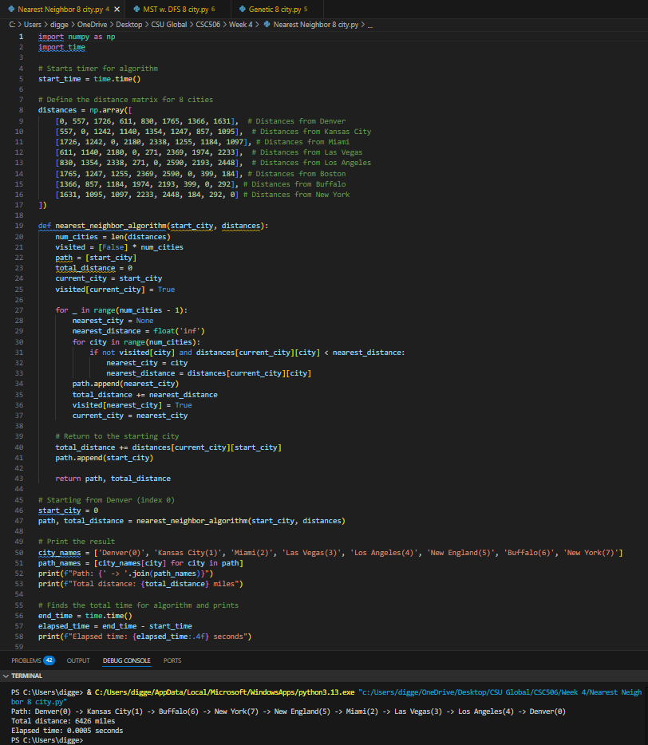

Minimum Spanning Tree Data Set B 8-city
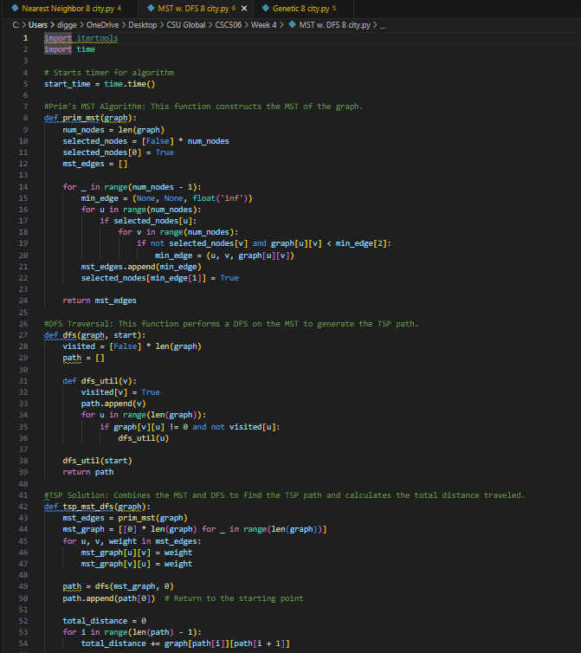
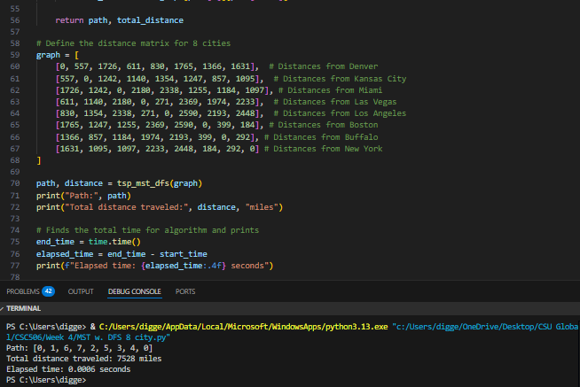
Genetic Data Set B 8-city
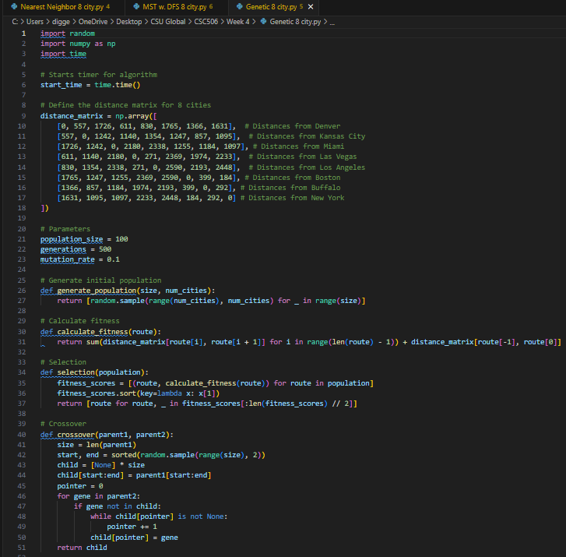

Nearest Neighbor Data Set C 12-city
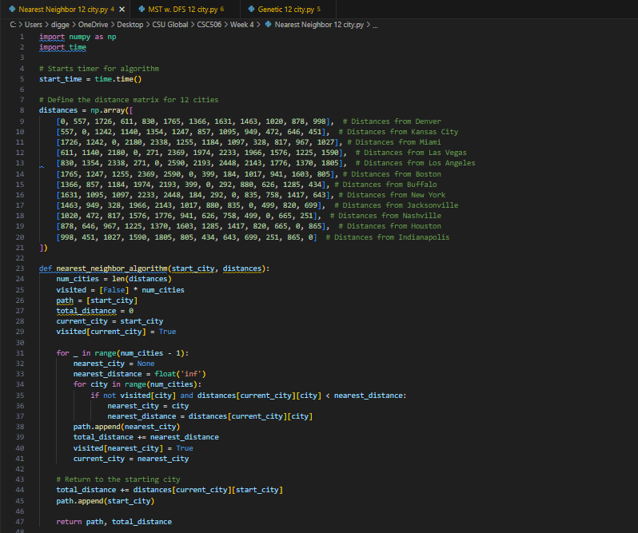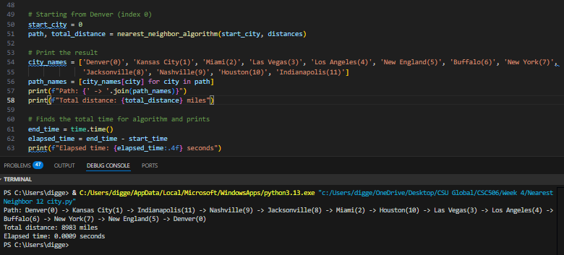
Minimum Spanning Tree Data Set C 12-city
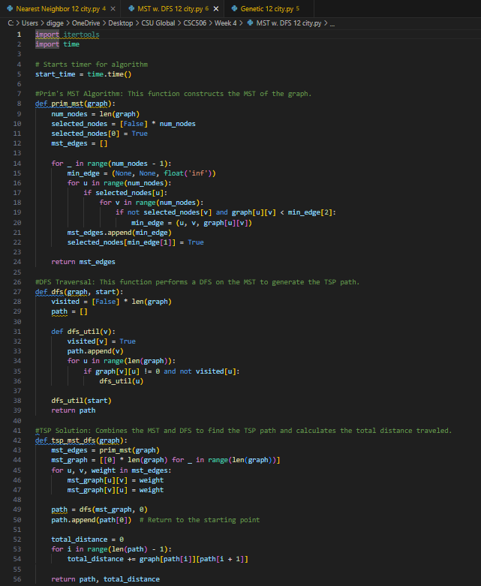
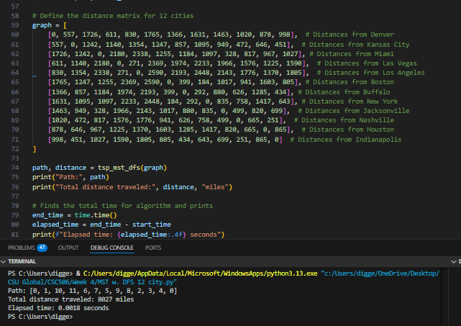
Genetic Data Set C 12-city
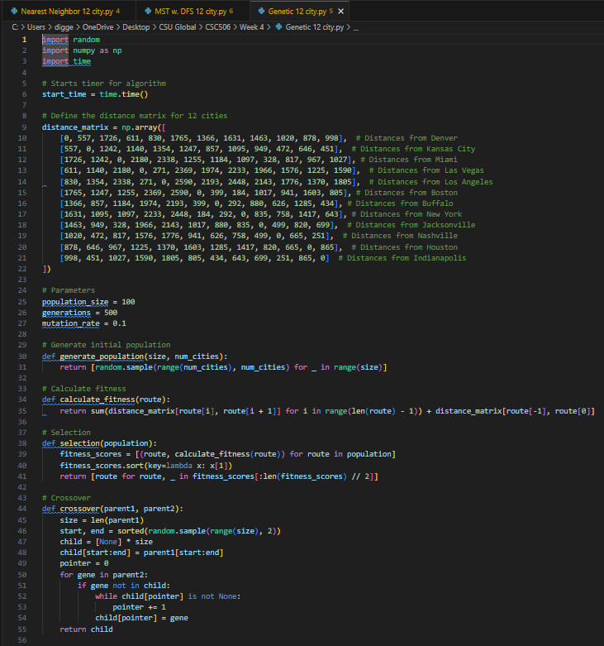
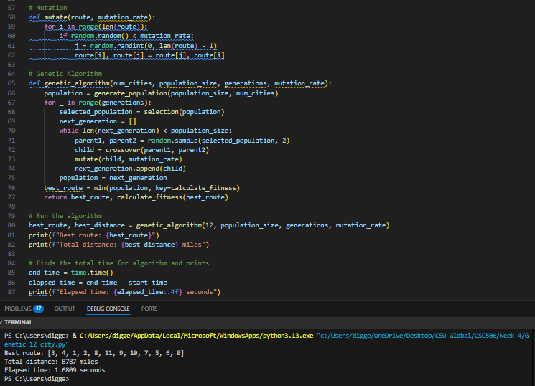
Results Table
Reflection
An interesting part of this milestone was deciding on what data to use for the Traveling Salesman Problem and how to set that up to be useful for the experiment. I considered using coordinates but opted for direct mileage from city to city since it felt like it would be easier to implement. I also didn’t feel that the general nature of city-to-city mileage instead of exact coordinates would work in this instance to provide an apples-to-apples view across the algorithms for performance. The result didn’t really matter if the actual mileage was off by some small percentage provided the same data input was being used for all the algorithms, especially since the experiment was about seeing how the algorithms perform against each other across the same data sets. Another variable that I played with was the initial generation, population and mutation values for the Genetic algorithm. For this stage of the experiment, I somewhat randomly set these values, but think this could be an interesting space to explore later once I’ve had an initial review of the data. Data review will be forthcoming in the next milestone, and I’m curious to see which algorithm gave the Denver Broncos the shortest trip and did so in the shortest amount of time.

Reference
Distance-Cities.com (2025). Distance-cities.com. Distance Between Cities.
https://www.distance-cities.com/

